UD85C08 8DI-8DO USB Relay Manual
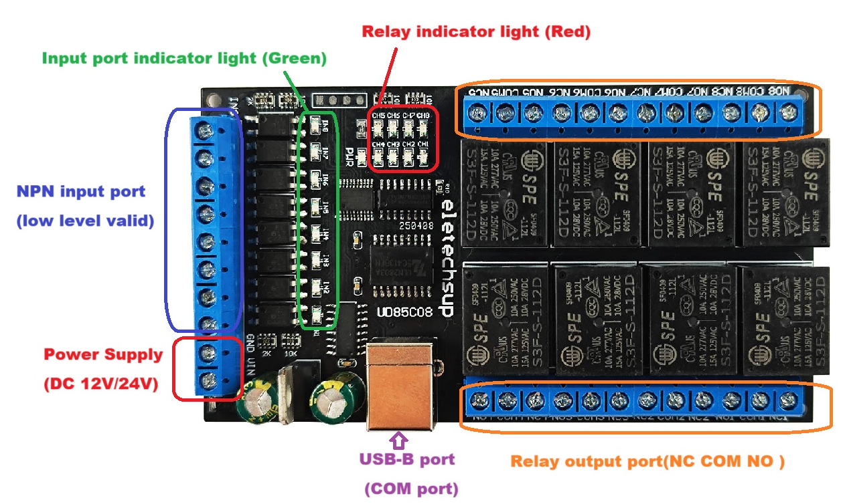
Features:
1: Working voltage: DC 12V/24V optional
2: (DC12V)Standby current (all relays closed) 12MA, 1 relay open 40MA, 2 relays open 68MA, 3 relays open 96MA,4 relays open 122MA,5 relays open 148MA,6 relays open 174MA, 7 relays open 199MA,8 relays open 223MA
3 8 photoelectric isolation Input ports (NPN low level active ), The input port directly controls the relay by default, and can also be set not to control the relay through instructions
4 UART serial port protocol, USB_B female interface (CH340 Chip)
5 USB interface supports Windows(WIN11 WIN10 WIN8 WIN7 WINXP), Linux and MAX OS
6: "ON" "OFF" "Self-locking" "Interlock" "Momentary" "Delay" “All Relays Open” “All Relays Close” 8 Commands
7 Two kinds of commands: AT command and 8-byte command, the two commands are automatically recognized, no need to switch.
8: Under the "Delay" command ,the maximum delay is 9999 seconds(Only AT command)
9 Size: 115 * 63 * 19mm
10 Weight: 124 g
11 Industrial Relays,Maximum load: 10A / 250VAC, 10A / 125VAC, 10A / 30VDC, 10A / 28VDC, 10A / 12VDC

Glossary:
IN1/2…8: Optically isolated input port, NPN input (active low)
NO : Relay normally open contact
COM : Relay common contact
NC : Relay normally closed contact
Open(ON) : NO connection COM, NC disconnect COM
Close(OFF) : NO disconnect COM, NC connection COM
Momentary : Enter the Momentary command, the Rreceiver Relay is Open, delay of 0.5 seconds after, Relay is Close;
Toggle : Enter the Toggle command, the Rreceiver Relay is Open, Enter the Toggle command again, Relay is Close;

Latched : Enter the Channel 1 Latched command, the receiver Channel 1 is Open, the Channel 2 is Close.
Enter the Channel 2 Latched command the receiver Channel 2 is Open, the Channel 1 is Close.
Enter the Channel 3 Latched command the receiver Channel 1 is Close, the Channel 2 is Close.

Delay : Enter the Delay command, the Rreceiver Relay is Open, delay of 0-9999 secondsafter, Relay is Close;
During the delay, Eter the Close command, immediately close the relay

Applications
Home Automation/Smart Home
Industrial Automation
Lighting Control
Garden Equipment Control
Test Fixtures
DIY and Hobby
Solenoid valve/motor/water pump control system

Wiring Diagram:
DC 1-110V/AC 1-265V control circuit,Wiring diagram below(Note:If not DC 12V24V load, need another DC 12V24V power supply). "LOAD" may be LED lights, fans, motors Lights, fluorescent lights, solar water heaters and other DC AC equipment
